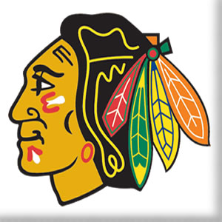
Six Nations Minor Hockey Association

Player Code of Conduct Agreement

As a player registered with the Six Nations Minor Hockey Association, I understand that I am representing my family, my teams, my association and my community. I will therefore conduct myself at all times, both on and off the ice in a respectful and sportsmanship manner
While playing/practicing hockey or attending any hockey related activity or function, I will follow all guidelines and established principles of Hockey Canada and OMHA’s “For Sake of Sport” Policy and any other leagues or association rules are applicable.
I will treat executive members, my coaches, my fellow players, my opponents and any other team or league officials with respect and dignity. I will never be under the influence of alcohol or any other illegal substance. I will never verbally or physically abuse an official. I will respect the Gaylord Powless Arena and all other opponents facilities at all times.
I understand that failure to comply with this Player Code of Conduct may result in disciplinary action in accordance with Six Nations Minor Hockey. Such actions may results in my losing the privileges which come with being a member of the Six Nations Minor Hockey Association, including the opportunity to participate in activities and events, both present and future.

Player’s Name:

Team:

Date:

